**Barrier Mapper User Guide**

*Version 1.1—Updated August 2016*

Brad McRae

The Nature Conservancy

**Acknowledgements**

Barrier Mapper builds on much of the Python code developed with **Darren Kavanagh** for Linkage Mapper (McRae and Kavanagh 2011)**.** I am grateful for Darren’s excellent contributions.

**Software Requirements and Licensing**

Barrier Mapper requires **AcrGIS 10.0** with the Spatial Analyst extension. This code is provided free of charge under a GNU General Public License. More details can be found on the Linkage Mapper website, where the code is hosted: <http://www.circuitscape.org/linkagemapper>.

**Preferred Citation** (Please obtain permission before citing).

McRae, B.H. 2012. Barrier Mapper Connectivity Analysis Software. The Nature Conservancy, Seattle WA. Available at: <http://www.circuitscape.org/linkagemapper>.

**Table of Contents**

1. Introduction 2

2. Installation 2

3. Using Barrier Mapper 2

3.1 Input data requirements 2

3.2 Running the toolbox 2

3.3 What Barrier Mapper does 4

4. Barrier Mapper tutorial 5

5. Support 7

6. Literature cited 8

# 1. Introduction

Barrier Mapper is part of the Linkage Mapper Toolkit, which includes Linkage Mapper (McRae and Kavanagh 2011) and other modules designed to support regional wildlife habitat connectivity analyses. Once corridors have been mapped using Linkage Mapper, Barrier Mapper detects important barriers that affect the quality and/or location of the corridors. Results are written to the Linkage Mapper output directory.

More details on the theory behind this approach can be found in McRae et al. (2012).

Please visit the project website and join the user group for updates at: <http://www.circuitscape.org/linkagemapper>.

# 2. Installation

**1) Install the ‘Linkage Mapper Arc 10’ toolbox.**

Follow the instructions in the Linkage Mapper User Guide to install the toolbox.

**2) Verify your installation**

You can test the code by running the tutorial below.

# 3. Using Barrier Mapper

## 3.1 Input data requirements

Barrier Mapper should be run after Linkage Mapper has been run through step 3 or greater (see the McRae and Kavanagh 2011). Inputs to Barrier Mapper include 1) the same resistance raster used in Linkage Mapper and 2) CWD rasters generated from a completed Linkage Mapper run. These rasters are located in the datapass directory, but you only need to provide the project directory for Barrier Mapper to find them.

## 3.2 Running the toolbox

*Note: ArcGIS can be finicky about file locks. If you get schema lock or permission errors, you may need to close ArcCatalog and ArcMap and start fresh without any output files displayed.*

*Note: Although this user guide was written with running from ArcMap in mind, several users have reported that they experience fewer ArcGIS errors when running from ArcCatalog.* ***We therefore suggest you run from ArcCatalog if you are having problems with the tool.***

*Please ensure that your resistance and core area maps are in the same projection. These tools have not been tested with data in different coordinate systems.* ***We strongly suggest that map units be in meters.***

Click on the *Barrier Mapper* tool inside of the *Linkage Mapper Arc 10* toolbox. The following dialog should appear.

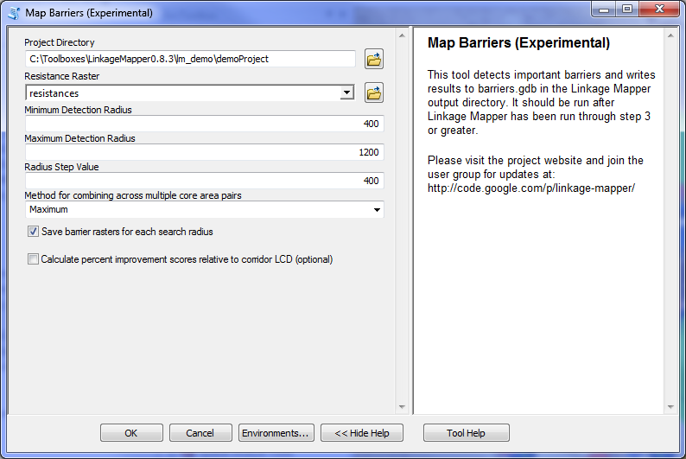

Figure 1. Barrier Mapper dialog. If the right-hand panel is not visible, click ‘show help’ at the bottom of the dialog to view it.

1. **Input data**
   1. **Project directory:** Use the same project directory used for the Linkage Mapper run.
   2. **Resistance raster:** Use the same resistance raster used to create corridors using Linkage Mapper.
2. **Options** 
   1. **Minimum detection radius:** Enter the minimum search radius for moving window analysis in map units. This is half the minimum length of a strip of land that could be restored, and must be greater than or equal to resistance raster cell size.

*Note: barrier detection radii should be larger than the cell size. Also, radii that are close to the cell size can produce results that exaggerate improvement scores due to rounding error.*

* 1. **Maximum detection radius:** Enter the maximum search radius for moving window analysis. This is half the maximum length of a strip of land that could be restored. If you only want to search at a single radius, enter the same value as you did for the minimum radius.
  2. **Radius step value:** Enter the increment in radius for each progressive window size. The difference in minimum and maximum radius should be divisible by this number. For example, a minimum of 100, a maximum of 500, and a step value of 200 would detect barriers at radii of 100, 300, and 500 map units. If you only want to search at a single radius, enter 0.
  3. **Method for combining across multiple core area pairs:** when there’s more than one core area pair to connect, Barrier Mapper needs to combine results into a single map. It can do this one of two ways:

*Maximum*: each pixel value will be set to the maximum improvement score taken across all core area pairs. Results will be written to barriers.gdb.

*Sum:* each pixel value will be set to the sum of improvement scores taken across all core area pairs. This gives a measure of 'barrier centrality.' Note that choices made in earlier Linkage Mapper run (adjacency, maximum corridor length, dropping corridors that pass through intermediate core areas) will limit the number of corridors that can be affected by restoration of a cell. Results will be written to barriers_sum.gdb.

* 1. **Write barrier rasters for each search radius:** If checked, barrier rasters will be saved for each search radius when analyses are run across multiple radii. If unchecked, only rasters summarizing results across search radii will be saved.
  2. **Calculate percent improvement scores relative to corridor LCD:** If checked, additional rasters calculating improvement score as a percentage of corridor least-cost distance (LCD) will be written. These will have 'Pct' in the raster name, and will have higher scores for corridors where the unrestored LCD is low, presumably meaning they are more viable to begin with.

## 3.3 What Barrier Mapper does

Barrier Mapper implements the methods described in McRae et al. (2012) using a circular search window. Results give expected reduction in least-cost distance (LCD) ***per unit distance restored*** assuming pixels in the window are changed to a resistance of **1.0**.

Outputs rasters will be written to barriers.gdb and/or barriers_sum.gdb in your output directory. Output rasters are named using the following convention:

<Project directory name>_<attributes>

**Attributes include:**

***BarrierCenters:*** Improvement scores are mapped at the center pixel for the search window.

***BarrierCircles:*** Improvement scores are expanded to fill the entire search window. For overlapping windows, the maximum value at each pixel will be shown.

***Sum:*** When there is more than one patch pair, the improvement score at any pixel represents the sum of improvement scores, rather than the maximum, across patch pairs.

***Pct:*** Improvement scores are expressed in terms of percentage improvement relative to original LCD (cost-weighted length) of corridor.

***RadX:*** Results for search radius X.

***RadXToYStepZ:*** Results summarized across search radii, from minimum search radius *X* to maximum *Y* with step intervals of *Z*. For example, a raster with an attribute of ‘Rad90To360Step90’ combines results from 90, 180, 270, and 360 m barrier analyses.

# 4. Barrier Mapper tutorial

After running the Linkage Mapper tutorial described in the Linkage Mapper User Guide (McRae and Kavanagh 2011), you can analyze barriers in your output corridors. Open up LM_demo_results.mxd, and run Barrier Mapper using the following settings (substitute the path to your own demo directory).

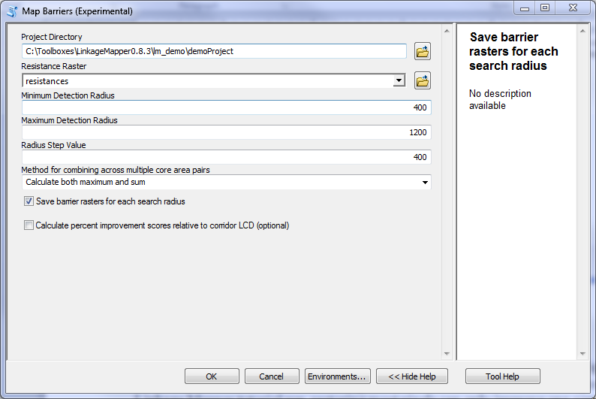

Figure 2. Tutorial settings. Replace the project directory with the directory you used for the Linkage Mapper tutorial run.

These settings will map barriers at 400, 800, and 1200 m and will summarize them across scales using both maximum and sum methods described above. Figure 3 shows results for barriers detected at the 1200 m search radius, and Figure 4 shows results combined across the 3 search radii. In Figure 4, results from both maximum and sum methods are shown. Note that these results are similar except for small differences (as indicated by arrows in Fig. 4). Their similarity is due to the settings used in the earlier Linkage Mapper tutorial run, which restricted the number of corridors mapped so that there were few areas affecting more than one corridor. As a result, restoring most pixels can only improve one corridor.

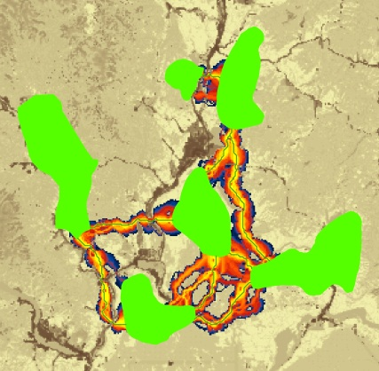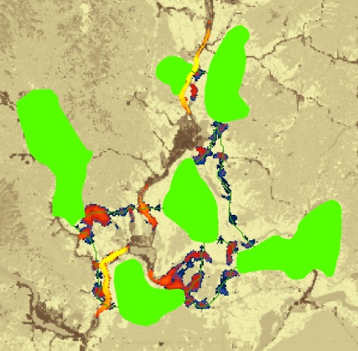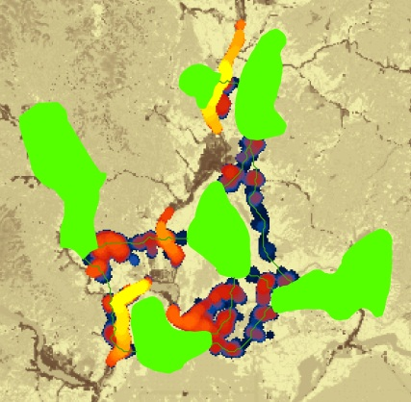

Improvement Score

(panels B and C)

∆LCD per m restored

Higher

Lower



**A**

**B**

**C**

Figure 3. A) corridors from Linkage Mapper tutorial, with least-cost paths shown in green (a total of 8 corridors were mapped). B) demoProject_BarrierCenters_Rad1200, which shows improvement scores at the center pixel for 1200m radius search window locations. Least-cost paths are shown for reference. C) demoProject_BarrierCircles_Rad1200, which shows same but improvement with scores expanded to fill the entire search window, with maximum score taken for overlapping windows.

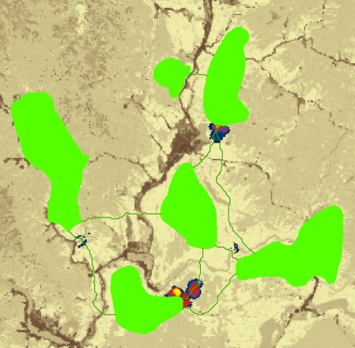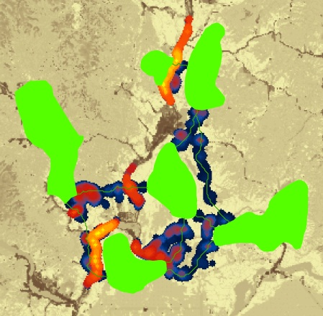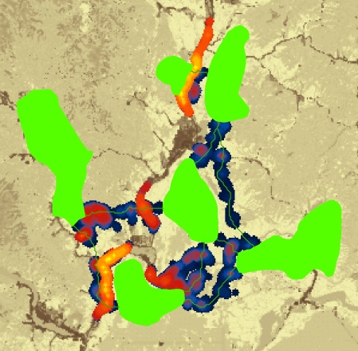

**A**

**B**

**C**

Figure 4. Results showing composite of barriers across 400, 800, and 1200 m window sizes. A) demoProject_BarrierCircles_Rad400To1200Step400, showing maximum per-meter improvement score mapped across search windows. B) demoProject_BarrierCircles_Sum_Rad400To1200Step400, in which improvement scores are summed across patch pairs at each scale before taking the maximum across scales. C) Difference between sum and maximum methods (greatest differences shown in yellow and do not exceed a ∆LCD of 1.5 meters ***per meter restored***). Results from taking the maximum per-meter improvement score and sum of scores mapped among pairs are very similar, with most significant differences in two areas where different corridors are in close proximity.

Figure 5 shows results of a second Linkage Mapper run with less restrictive settings. In this scenario, there were no limitations on maximum corridor length and corridors were allowed to pass through intermediate core areas (i.e. the box to drop corridors that intersect core areas in step 3 was not checked). With these settings, an additional 2 corridors were mapped (Fig. 5A). Because there are more cases in which corridors occur in close proximity to one another, there are more areas where restoration could improve multiple corridors. As a result, there are more substantial differences between maximum and sum methods. These differences show where a single restoration could improve multiple corridors.

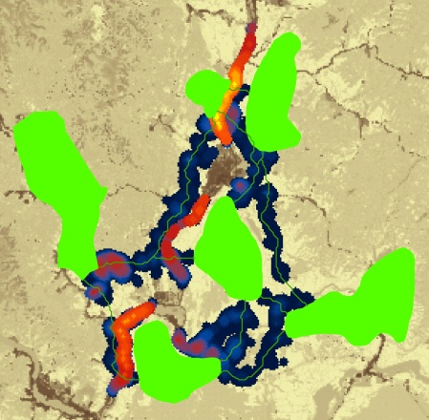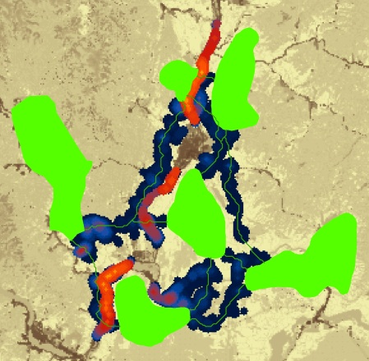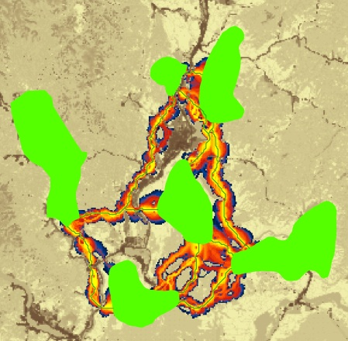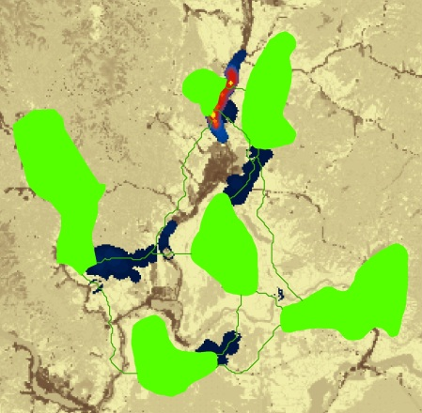

**A**

**B**

**C**

**D**

Figure 5. Linkage and barrier analysis with more core areas connected (no distance cutoffs and corridors were allowed to pass through intermediate core areas). A) corridors, with least-cost paths shown in green (a total of 10 corridors were mapped). B) composite of barriers across 400, 800, and 1200 m window sizes, with maximum per-meter improvement score mapped across search windows (analogous to Fig. 4A). C) same as upper right, except improvement scores are summed across patch pairs (analogous to Fig. 4B). D) difference between maximum and sum results, with greatest differences in yellow (maximum ∆LCD ***per meter restored*** = 42.6). There are more substantial differences between the maximum and sum methods here than in Fig. 4 because there are more areas where multiple corridors could be improved through restoration of a single area.

# 5. Support

Please join the Linkage Mapper User Group to get updates, report bugs, and suggest enhancements. You can find a link to the user group on the Linkage Mapper website, where our code is hosted: <http://www.circuitscape.org/linkagemapper>.

# 6. Literature cited

McRae, B.H., S.A. Hall, P. Beier and D.M. Theobald. 2012. Where to restore ecological connectivity? Detecting barriers and quantifying restoration benefits. PLoS ONE 7(12): e52604. doi:10.1371/journal.pone.0052604

McRae, B.H. and D.M. Kavanagh. 2011. Linkage Mapper Connectivity Analysis Software. The Nature Conservancy, Seattle WA. Available at: <http://www.circuitscape.org/linkagemapper>.